Gabriel Porter

Aerospace Mechanics 1 (Orbits)

3613 – 102

Donna Jennings

Homework #1

1. Completed Reading
2. Scored 10/10 on syllabus quiz
3. A spherical planet, “Planet X” has an equatorial radius $R_{x}$ of $5R_{⊕}$ and a density $ρ_{x}$ of $5ρ_{☿}$. The necessary equations are the scalar form of Newton’s Universal Law of Gravitation, $F_{G}=G\frac{m_{1}m_{2}}{r^{2}}$, Where $m$ is mass, $r$ is the distance between the COM (center of mass) of the two bodies, $F_{G}$ is the force of gravity, and $G$ is the universal gravitational constant, $G≈6.6743∙{10}^{-11}\frac{m^{3}}{kg∙s^{2}}$, and the scalar form of Newton’s Second Law, $F=m∙a$, where $a$ is acceleration.
   1. When the Falcon is 1 AU away from the center of the planet the gravitational force $F_{G}$ is given to be 2.5 N. Find the mass of the Falcon in metric tons and US tons.
      1. To determine $m_{falcon}$, units are converted to be consistent. 1 AU is approximately $1.496∙{10}^{11}$ meters, so $r≈1.496∙{10}^{11}$ meters. The remaining values are already in consistent units.
      2. Newton’s Universal Law of Gravitation is rewritten using non-generic variables, $F_{G}=G\frac{m_{x}m_{falcon}}{r^{2}}$, and is rearranged to solve for $m_{falcon}$: $\frac{r^{2}∙F_{G}}{G∙m_{x}}=m_{falcon}$.
      3. $m_{x}$ (mass of Planet X) must be found to calculate $m_{falcon}$.
      4. $m_{x}=ρ_{x}∙V_{x}$ where $V_{x}$ is the volume of planet X and $ρ_{x}=5ρ_{☿}$. Since Planet X is a perfect sphere, $V_{x}=\frac{4}{3}π{R_{x}}^{3}$, where $R_{x}=5R_{⊕}$. By substituting these values for $ρ_{x}$ and $R_{x}$, the new equation is as follows: $m_{x}=5ρ_{☿}∙V_{x}=\frac{4}{3}π{{(5R}_{⊕})}^{3}$. The equatorial radius of planet Earth, $R_{⊕}$, is approximately $6.371∙{10}^{6}$ meters, and the density of planet Mercury $ρ_{☿}$ is approximately $5429\frac{kg}{m^{3}}$. Using these values, $m_{x}≈3.676∙{10}^{27}$ kg.
      5. Since all values other than $m_{falcon}$ have been defined, the rearranged gravitational equation can now be solved to get $m_{falcon}≈2.281∙{10}^{5}$ kg.
      6. To find the mass of the Falcon in metric tons and US tons the conversion factors $1 metric ton=1000 kg$ and $1 metric ton ≈1.102 US tons$ are used to get that the Millennium Falcon is approximately $228.08 metric tons$, or approximately $251.41 US tons$.
   2. The Falcon’s thrusters fail, and the craft begins to drift towards the planet, at one point recording a gravitational acceleration, $a_{G}$, of $0.1g$; where $g$ is the acceleration due to gravity at sea level on planet Earth. Find the distance of the Falcon to the center of Planet X in kilometers (assume the Falcon is a point mass).
      1. To find the distance between the COMs of Planet X and the Falcon, both Newton’s Universal Law of Gravitation and Newtons Second Law must be used.
      2. Since $a_{G}$ is given to be $0.1g$, and $g$ is known to be approximately $9.807 \frac{m}{s^{2}}$, the force $F$ in Newton’s Second Law is the force due to gravity, $F_{G}$, and the equation can be written as $F_{G}=\frac{{g∙m}_{falcon}}{10}$. This is the same force found in the gravitational equation, so for this instance the second law equation can be substituted in to the gravitational equation as follows: $\frac{{g∙m}_{falcon}}{10}=G\frac{m_{x}m_{falcon}}{r^{2}}$.
      3. The equation is now rearranged to solve for the distance between the COMs of the two bodies: $r=\sqrt{10∙\frac{G∙m_{falcon}∙m_{x}}{m_{falcon}∙g}}$, and further $m_{falcon}$ divides out to get a simplfied equation: : $r=\sqrt{10∙\frac{G∙m_{x}}{g}}$.
      4. All values other than $r$ are known, so the equation can be solved to get $r≈5.0014∙{10}^{8}$ meters, which is simply $5.0014∙{10}^{5}$ kilometers, meaning that the distance between the Millennium Falcon and the center of Planet X is approximately $5.0014∙{10}^{5}$ kilometers.
   3. Plot the magnitude of the gravitational force between Planet X and the Millennium Falcon as a function of distance ranging from the initial position (1 AU) to the planet’s surface ( $R_{x}$ meters from the planets center).
      1. Maximum distance is given as 1 AU, or $r_{max}≈1.496∙{10}^{11}$ meters, and minimum distance is given as the planet’s surface, or $r_{min}≈3.186∙{10}^{7}$ meters.
         1. $r_{min}=R_{x}$, $R_{x}=5R_{⊕}$, $R_{⊕}≈6.371∙{10}^{6}$ meters, so $R_{x}≈3.186∙{10}^{7}$ meters.
      2. $r$ is converted from meters to kilometers to get $r_{max}≈1.496∙{10}^{8}$ kilometers, and $r_{min}≈3.186∙{10}^{4}$ kilometers.
      3. $r$ in Newton’s Universal Law of Gravitation equation is now used as an independent variable ranging from $r_{max}$ to $r_{min}$: $F_{G}=G\frac{m_{x}m_{falcon}}{r^{2}}$, and MatLab is used to plot the result. (figures 1 and 2)

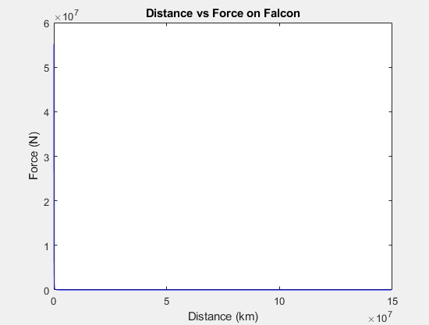

Figure 1 (Basic viewing window)

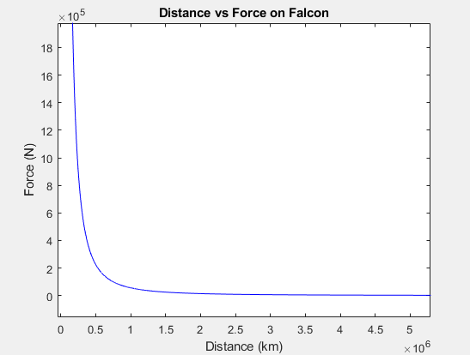

Figure 2 (Zoomed viewing window)

* 1. To plot the magnitude of the gravitational force between Planet X and the Millennium Falcon an initial value problem must be set up.
     1. Distance, $r$, must be written as a function of time by rewriting Newton’s Second Law as $a_{G}=\frac{F_{G}}{m_{falcon}}$.
     2. Both acceleration, $a$, and force, $F_{G}$, must be taken as functions of time to get $a_{G}(t)=\frac{F_{G}(t)}{m_{falcon}}$.
     3. Newton’s Universal Law of Gravitation is also written with respect to time: $F_{G}(t)=G\frac{m_{x}m_{falcon}}{{(r\left(t\right))}^{2}}$
     4. Solve the initial value problem for $r\left(t\right)$ using the initial conditions $r\left(0\right)=1 AU$ and assume $v\left(0\right)=0 \frac{m}{s}$, and $a\left(0\right)=0 \frac{m}{s^{2}}$.
     5. Replace $r$ in the gravitational equation with the equation $r\left(t\right)$ and plot the resulting equation, $F_{G}(t)$, against time.

1. Emailed professor
2. SpaceX’s “monopolization” of the space industry and its effects on other launch vehicle companies domestic and abroad.
   1. SpaceX has arguably dominated the space industry since NASA began contracting most of its missions to them in 2008. This meant that the government primarily supported SpaceX and was very biased in outsourcing their projects directly to them over other companies. While this may have led to SpaceX having something of a monopoly in the space industry, it seems to be for the best considering their numbers and accomplishments to date, although personally I think most of SpaceX’s numbers and accomplishments are grossly embellished or could be just as easily achieved by any other semi-decent contractor.
   2. The Artemis program aims to achieve regular manned missions to the moon as well as to serve as a sort of precursor to the Mars project. Personally, I see no point in these missions other than to say that we as a species are regularly travelling to other celestial bodies. It seems very premature for us to attempt such expensive and challenging missions with such little justification. If I were to change something about the Artemis missions it would be to do away with them altogether and focus on more relevant and cost-effective missions in their stead.
   3. Considering the complications encountered by Boeing’s Starliner I would understand the astronauts’ concern with using it as their primary vehicle. If NASA and Boeing conclude that it’s perfectly safe to use the vehicle to return to Earth, I would value their opinions over those of the two astronauts, especially with how expensive it would be to send up another craft just so they could feel a bit more comfortable on their journey back. Again, that is assuming NASA and Boeing found the craft to be perfectly safe for the astronauts return, if the craft is less than safe in any way but NASA decides it’s better to save money by using Starliner, the astronauts’ lives are certainly more important than saving a bit of money.

Citations:

* Encyclopedia Britannica, "Gravitational Constant," Encyclopedia Britannica. [Online]. Available: https://www.britannica.com/science/gravitational-constant. [Accessed: 23-Aug-2024].
* **NASA Jet Propulsion Laboratory (JPL)**, "Astronomical Unit (AU)," CNEOS. [Online]. Available: <https://cneos.jpl.nasa.gov/glossary/au.html>. [Accessed: 23-Aug-2024].
* **NASA’s National Space Science Data Center (NSSDC)**, "Earth Fact Sheet," NASA. [Online]. Available: <https://nssdc.gsfc.nasa.gov/planetary/factsheet/earthfact.html>. [Accessed: 23-Aug-2024].
* **NASA’s National Space Science Data Center (NSSDC)**, "Mercury Fact Sheet," NASA. [Online]. Available: <https://nssdc.gsfc.nasa.gov/planetary/factsheet/mercuryfact.html>. [Accessed: 23-Aug-2024].
* **Metric Conversions**, "Metric Tons to Short Tons," [Online]. Available: <https://www.metric-conversions.org/weight/metric-tons-to-short-tons.htm>. [Accessed: 23-Aug-2024].

MATLAB output

>> hwk01_prob3

Problem 3a

Mass of Millennium Falcon: 228.08 metric tons

Mass of Millennium Falcon: 251.41 tons

Problem 3b

Distance of Millennium Falcon from center of planet: 500138.65 km

Problem 3c

>>

MATLAB Code

%--------------------------------

disp('Problem 3a');

R = 5*(6.371e+06); % Planet radius

row = 5*5429; % Planet Density

r = 1.496e+11; % Distance of falcon to planet mass center

G = 6.67430e-11; % Universal gravitational constant

F = 2.5;

% Density to mass

m_planet = (row)*(4/3)*pi*(R^3);

% Mass of falcon

m_falcon = (F*(r^2))/(G*m_planet); % kg

m_falcon_mtons = m_falcon / 1e3; % metric tons

m_falcon_tons = m_falcon_mtons*1.10231; % tons

fprintf('Mass of Millennium Falcon: %.2f metric tons \n', m_falcon_mtons);

fprintf('Mass of Millennium Falcon: %.2f tons \n', m_falcon_tons);

%---------------------------------

disp('Problem 3b');

g = 9.807; % m/(s^2)

a = 0.1*g;

dist = sqrt((G*m_planet)/a); % Meters

dist_km = dist/1000; % km

fprintf('Distance of Millennium Falcon from center of planet: %.2f km \n', dist_km);

%--------------------------------

disp('Problem 3c');

num_points = 1e6; % Number of points to plot

distance = linspace(r, R, num_points); % Meters

distance_km = distance / 1000; % km

force = (G * m_planet * m_falcon) ./ (distance .^ 2); % Newtons

figure(1);

plot(distance_km, force, 'b');

xlabel('Distance (km)');

ylabel('Force (N)');

title('Distance vs Force on Falcon');